**CMPS 350 Project Phase 1 – Report**

**Education Platform**

**(10% of the course grade)**

**The report must be submitted in Word format only**

|  |  |
| --- | --- |
| **Group Members** | Aiman Alhetari (202104619)  Abdelrahman Kotb (202205705)  Ahmed Mohamed (202003797)  **Emails:** aa2104619@qu.edu.qa; ak2205705@qu.edu.qa; am2003797@qu.edu.qa; |
| **GitHub link** | https://github.com/aimanalhetari/web-project.git |

**Grades :**

**The student fills only the “Implementation Percentage”: Please specify either: *Working (completed x%)*, *Not Working (completed x%)* or *Not done*.**

|  |  |  |  |  |
| --- | --- | --- | --- | --- |
| **Criteria** | **Points** | **Implementation Percentage** | **Implementation Quality** | **Your Grade** |
| Design and implement the app Web UI and navigation using HTML, CSS and JavaScript. Including designing the App Web UI and navigation. | 50 | Working 100% |  |  |
| Design and implement the Web API and data access repositories to read/write the app data JSON files. | 30 | Working 100% |  |  |
| Application modeling (e.g. UML diagrams) to explain the data entities and the functionalities | 5 | Working 100% |  |  |
| Testing documentation using screen shots illustrating the testing results. | 5 | Working 100% |  |  |
| Team work quality. Contributions of team members - All members should collaborate and contribute equally to the project. | 5 | Working 100% |  |  |
| Project report – description of the implemented app, what is implemented, what is missed .. | 5 | Working 100% |  |  |
| **Total** | 100 |  |  |  |
| **Plagiarism, outsourcing, free riders** | -100 |  |  |  |
| **Delivery behind the deadline** | -5 |  |  |  |

**Important remark: In case of copying and/or plagiarism or not being able to explain or answer questions about the implementation, you lose the whole grade.**

**\* Criteria for grading the functionality:**

- The functionality is working: you get 70% of the assigned grade.

- The functionality is not working: you lose 40% of assigned grade.

- The functionality is not implemented: you get 0.

- The remaining grade in all cases from above **is assigned to the quality of the implementation**,

- The grades are distributed on the various use cases, when the design/implementation is partial, you get only the grades of designed/implemented use cases.

Code quality criteria, include:

- Use of meaningful identifiers for variables and functions (e.g. using JavaScript naming conventions)

- Pages are responsive

- Clean code: simple and concise code, no redundancy

- Clean implementation without unnecessary files/code

- Use of comments where necessary

- Proper code formatting and indentation.

**You lose marks** for code duplication, poor/inefficient coding practices, poor naming of identifiers, unclean/untidy submission, and unnecessary complex/poor user interface design.

**Important Remark**:

**[Grades: 100-85]:** Will be given only to **fully functional application** with **all the quality criteria cited above met** and the project has excellent **design for the various functionalities**. **The report is professional**.

**[Grades: 85-80]:** Will be given only **to functional application** **with most of all the quality criteria cited above met** and the project has good design for the various functionalities. **The report is professional**.

**[Grades: 80-75]:** 80% of the application functionalities are functional. The project respects partially the quality criteria. **The report is professional** but misses some information.

The grades are not negotiable. We expect that only a small portion (around 15%) of the class will be able to meet the criteria for the grades **[100-85]. You should work hard to and demonstrate the merits of your application to earn those grades.+**

# Description of your proposed platform

The proposed web platform is a role-based course management system designed to serve three types of users: students, instructors, and administrators. Each user type is granted specific functionalities based on their role, with the goal of streamlining the course registration, learning, and administration processes in an academic environment.

Student Functionality

Upon successful login or registration, student users are directed to the main page, which displays a list of all available courses by default. Students can refine their search using filters based on course name (e.g., JavaScript, OOP) or course category (e.g., Databases, Programming). Once a course is selected, the student is directed to the registration page, where multiple class sections (taught by different instructors) for the selected course are displayed.

Students are allowed to register for a course only if three conditions are met:

1. They have successfully completed all prerequisite courses and if the perquisite is in the in progress course as we considered the date after the drop course which means that the student has to successfully finish the course.
2. The course is currently open for registration.
3. The course has available seats

If the student meets these conditions and the selected class still has available slots, registration proceeds. A confirmation message is displayed upon successful registration, and course data is updated accordingly. However, the registration remains pending until officially validated by an administrator.

The platform also features a navigation bar, through which students can access their profile page. The profile page presents a comprehensive overview of the student’s learning path, including:

* Courses completed successfully (with corresponding grades),
* Courses currently in progress,
* Courses pending approval (i.e., registration submitted but not yet validated or started).
* Courses remaining

Instructor Functionality

After logging in, instructors are redirected to their main page, which categorizes their assigned classes into three sections: In Progress, Pending, and Completed.

* In Progress: These are active classes where the instructor can click to access the grades page. In this page, the instructor can view the list of enrolled students and is allowed to input and submit their grades for record-keeping.
* Pending: These are classes that have not yet been validated by the administrator. Although the instructor can access the grades page for pending classes, the system will not allow grade submission until the class is officially validated and moved to the "In Progress" category.
* Completed: This section includes all courses that have been finished after the instructor submitted the final grades for students in the "In Progress" classes.

This structured view helps instructors clearly distinguish between the status of their classes and manage their responsibilities efficiently.

Administrator Functionality

Administrators gain access to a centralized dashboard after login, which displays all Pending courses and classes. These are courses or class sections that have not yet been validated. Administrators have the authority to officially validate them, upon which their status changes to In Progress, allowing them to begin.

If an administrator chooses to unvalidate a course or class, it is effectively deleted from the system as a pending item. This mechanism ensures that only courses with sufficient student interest and appropriate setup proceed to the learning phase. Additionally, administrators have the capability to create new courses and assign instructors to specific class sections, enabling full control over academic offerings and scheduling.

**Sketch:**

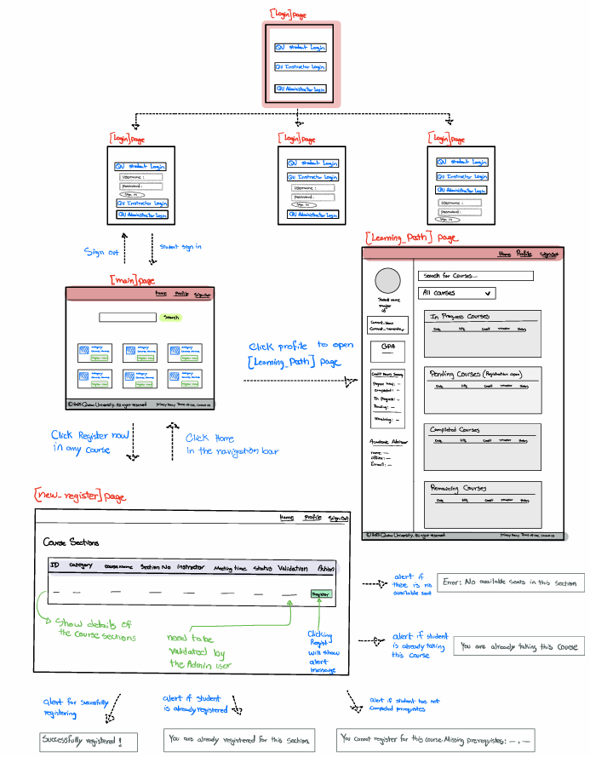

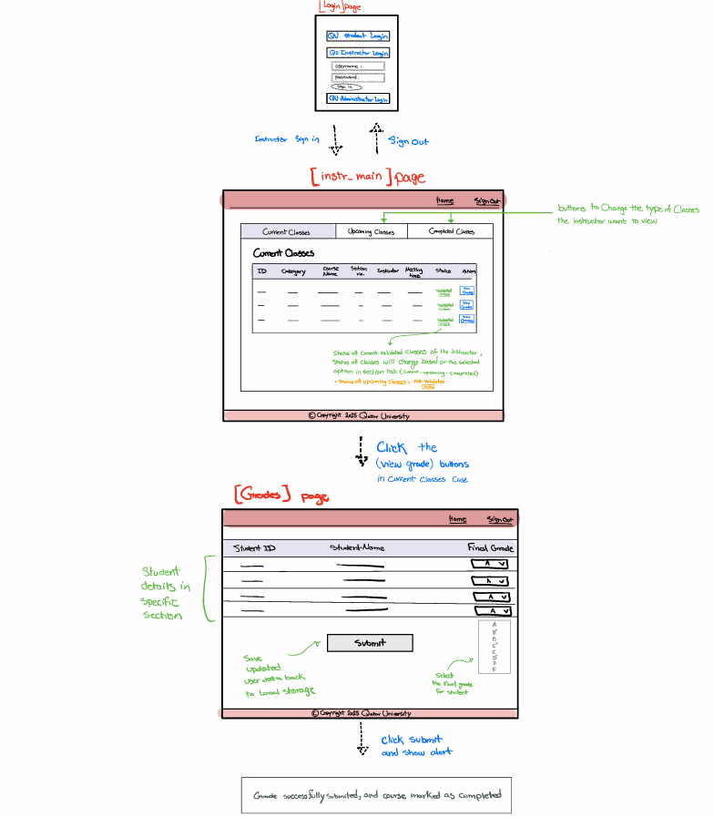

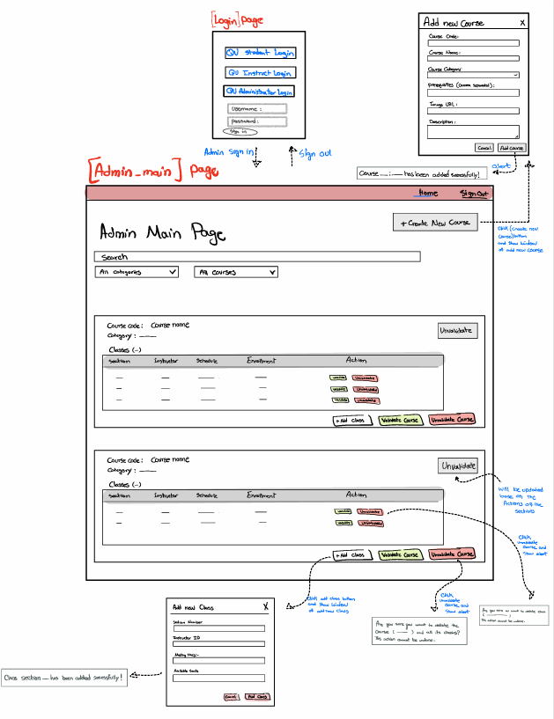

# Application Design

# Use case diagram

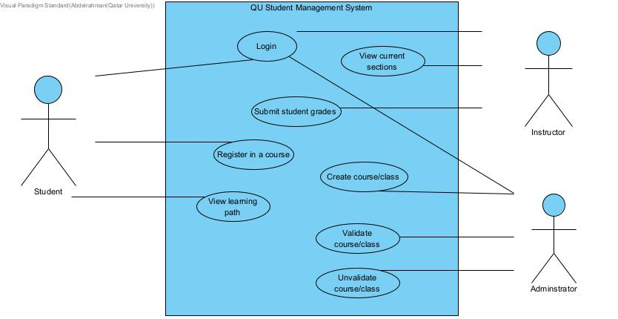

# Entities class diagram

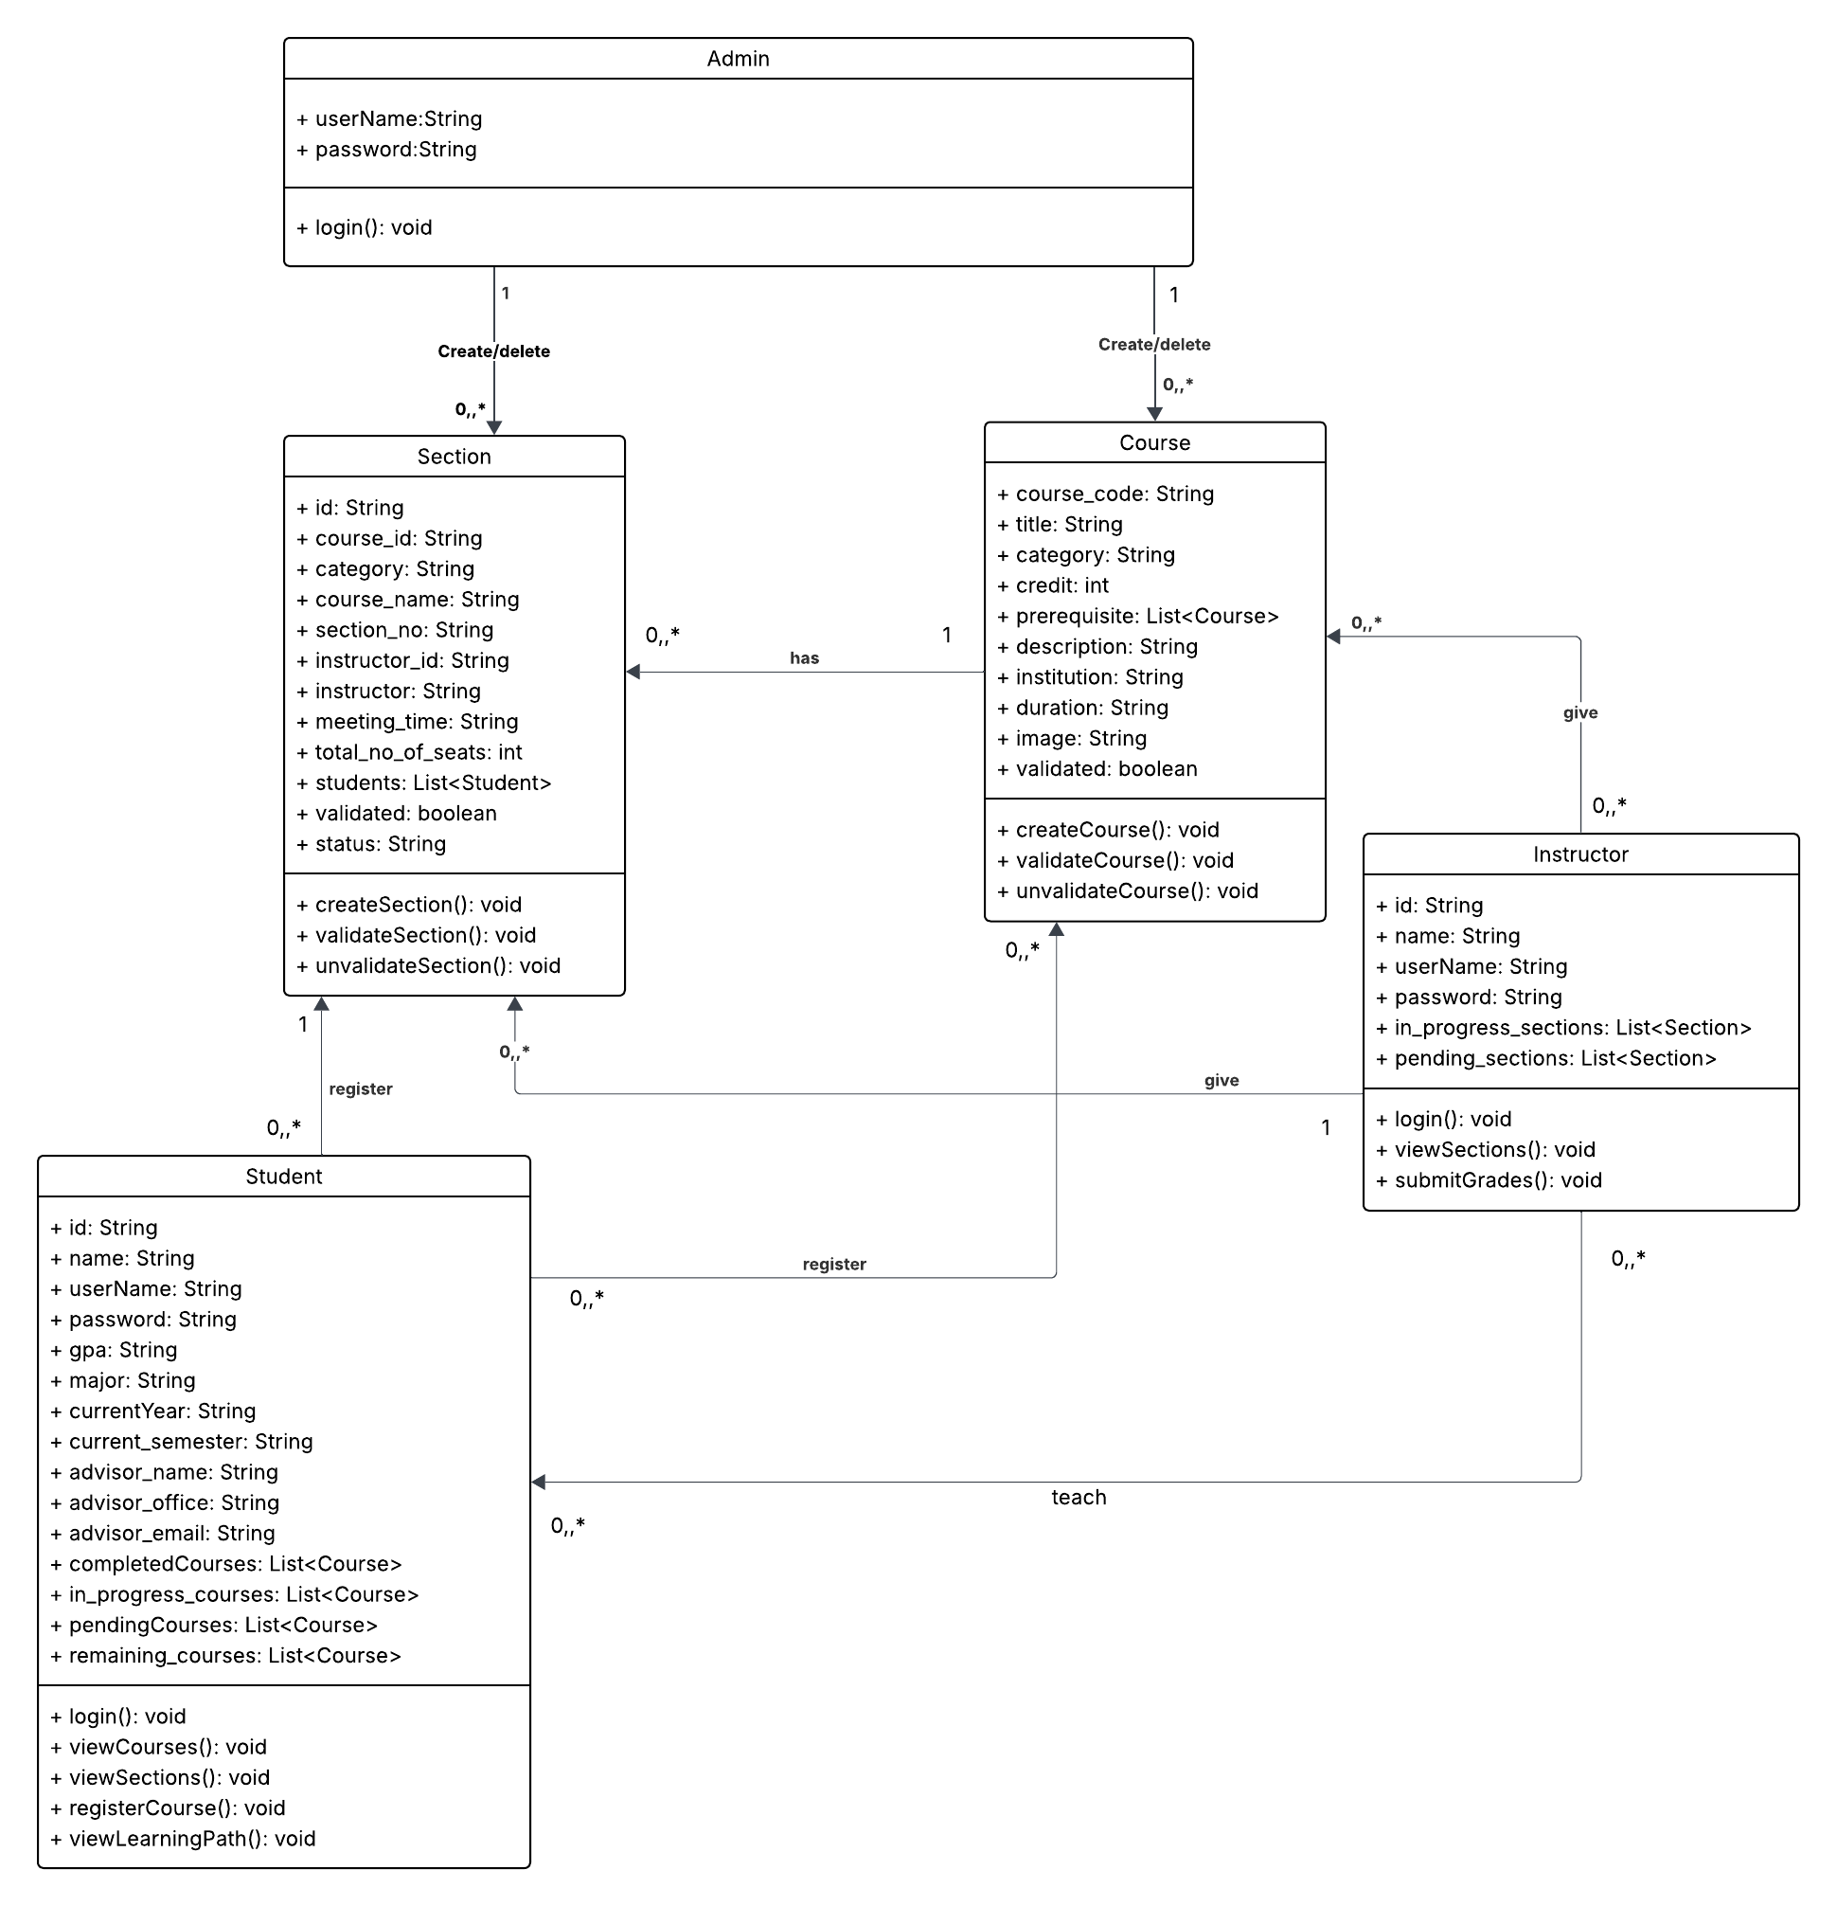

# Web API class

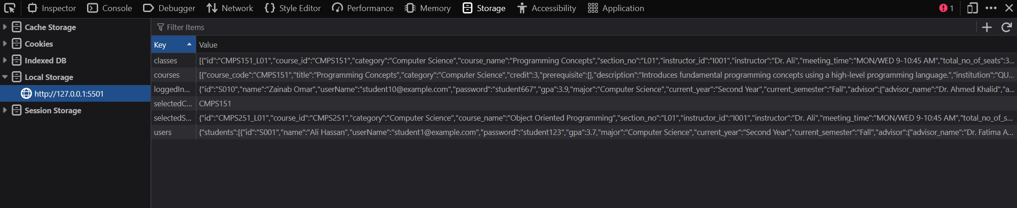

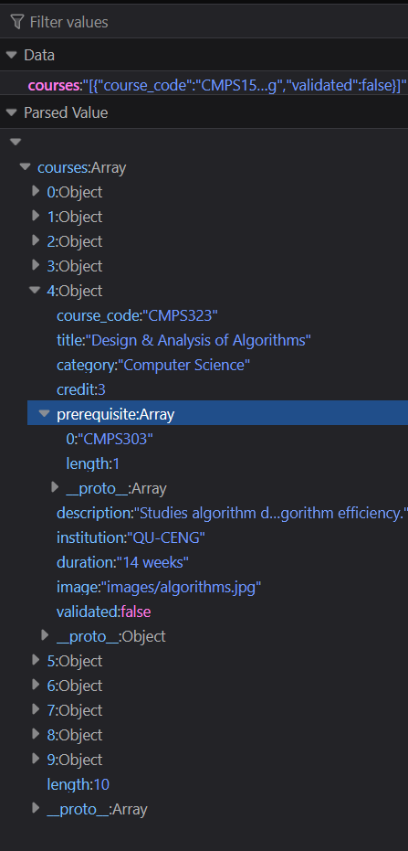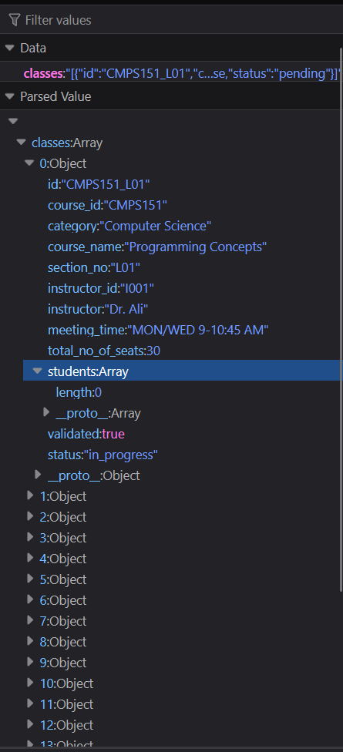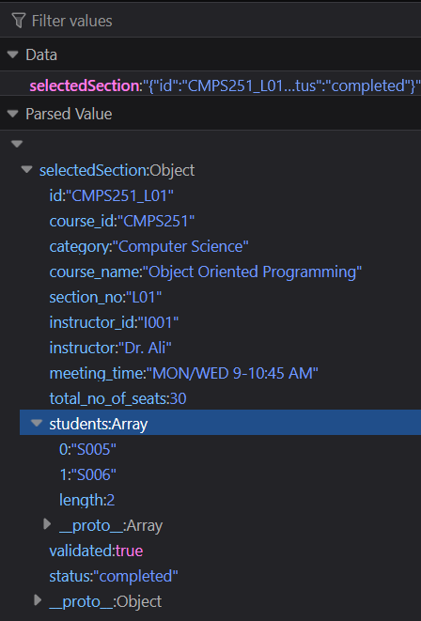

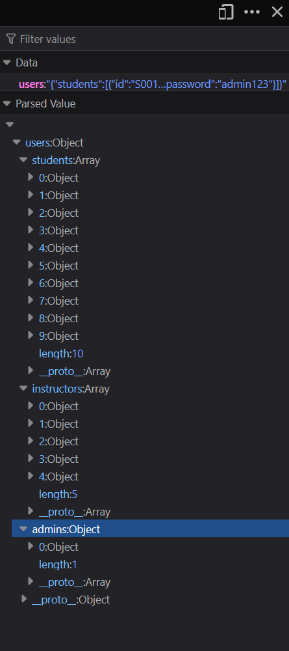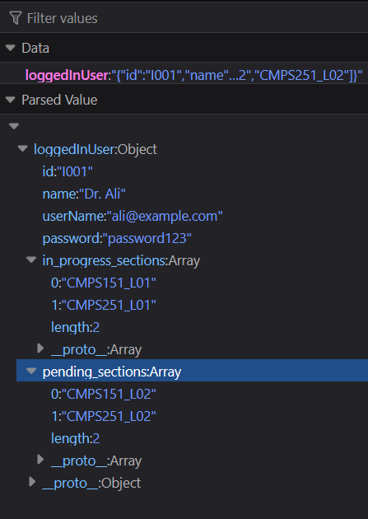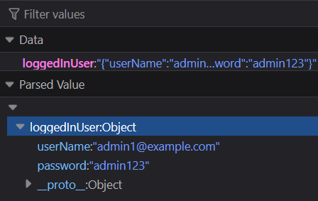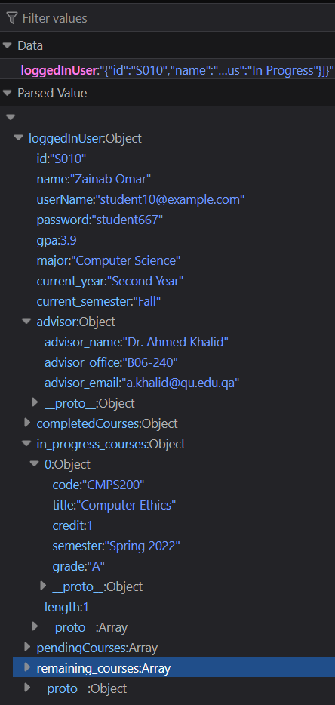

# Implementation

# Implemented use-cases

Use Case 1: Login

Use Case 2: Search and display available courses

Use Case 3: Register in a course

Use Case 4: View their learning path

Use Case 5: Creating / validating courses and classes

Use Case 6: Grades submission

# Unimplemented use-cases and not functioning parts

In use case (5): The administrator when they log on, they should see all courses that are currently in

progress and those open for registration. However, we did not implement this. Instead we assumed that the admin can only validate and unvalidate pending courses/classes only, assuming that in progress courses are already validated and can not be deleted. Therefore, the admin can only view all courses that are pending and those open for registration.

# Testing

# Use case 1



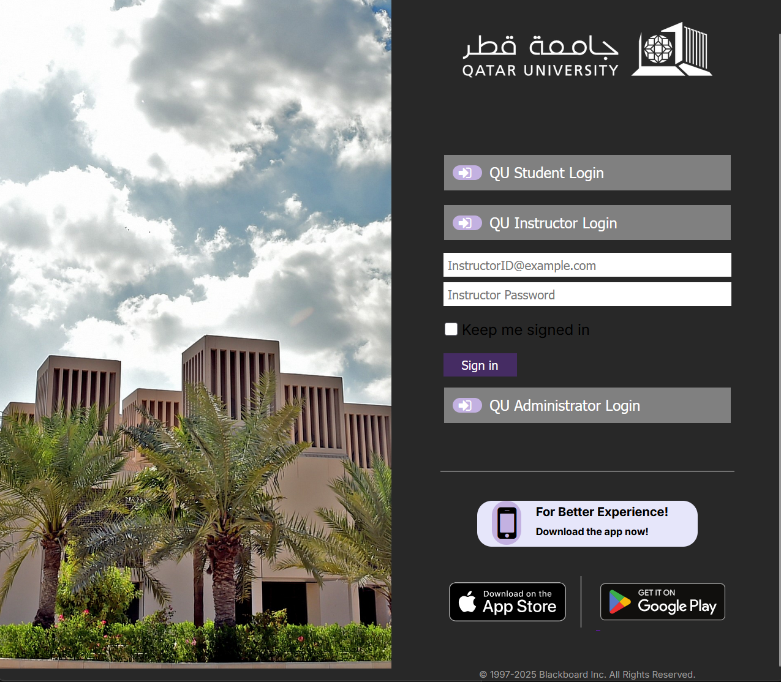

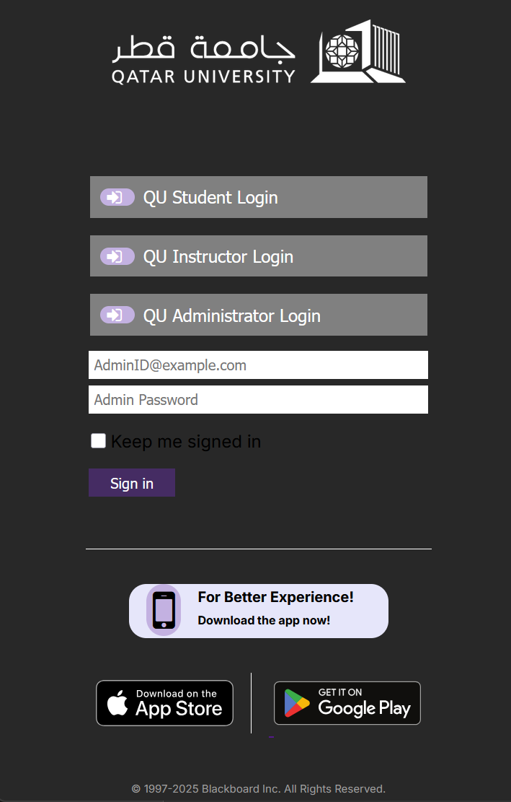

# Use case 2



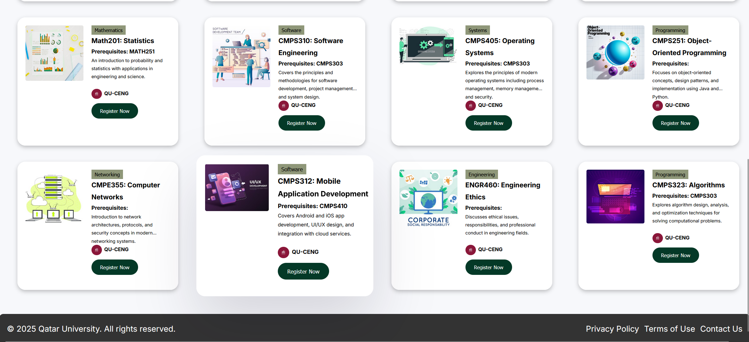

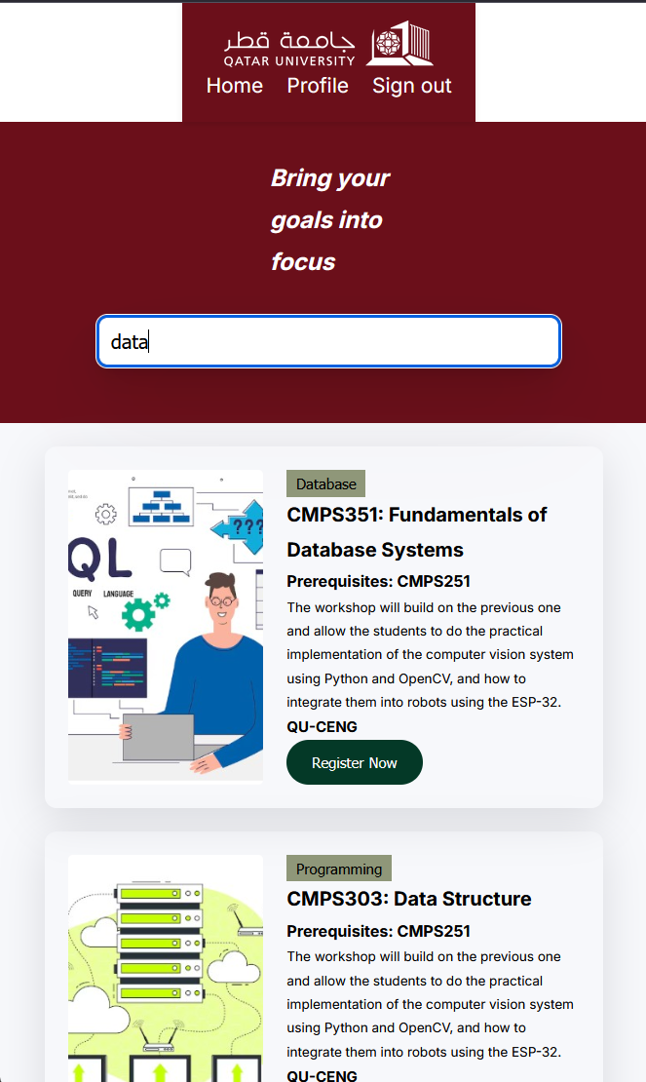

# Use case 3

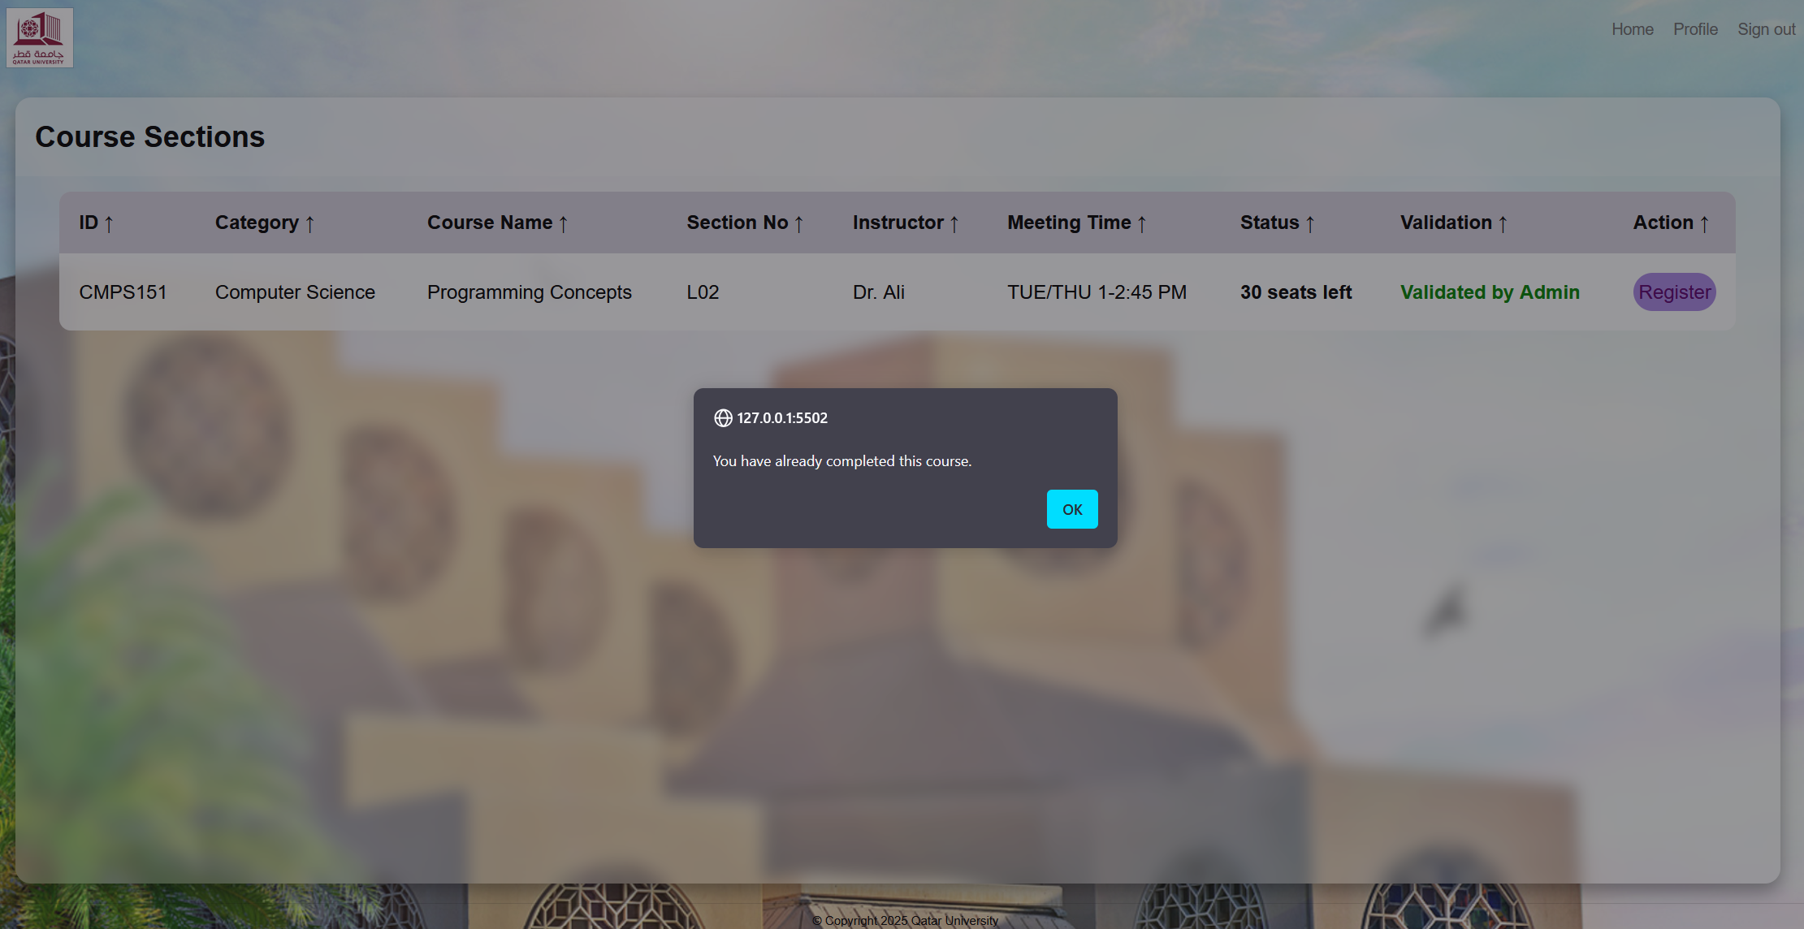

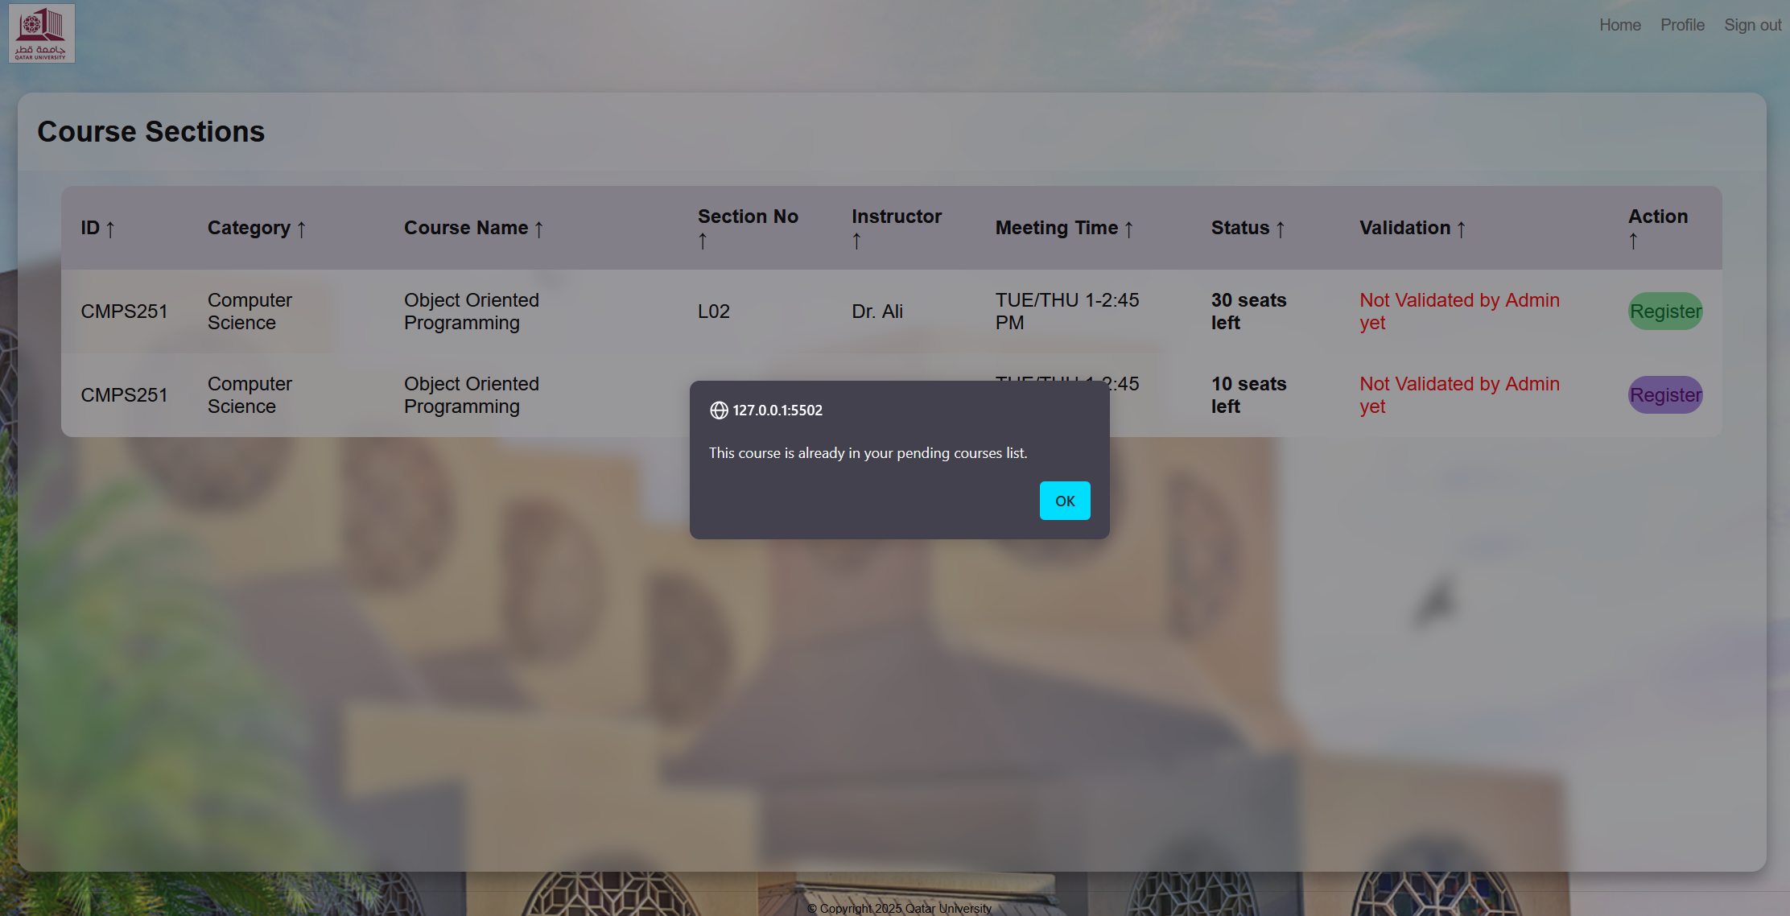

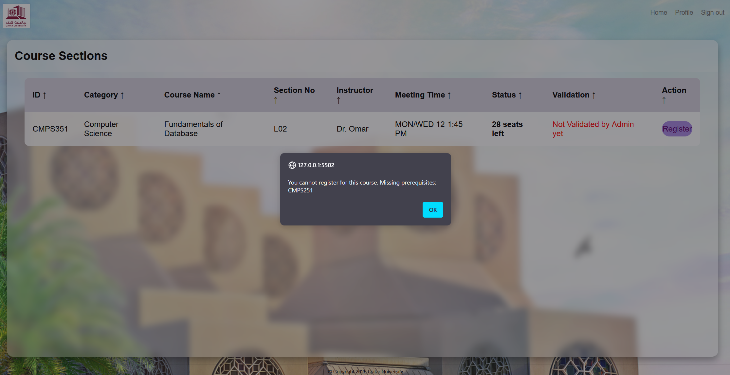

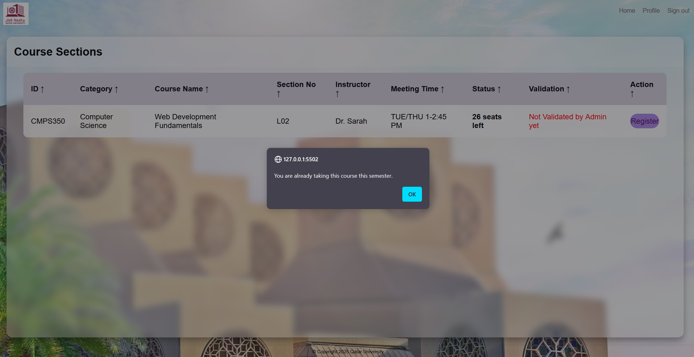

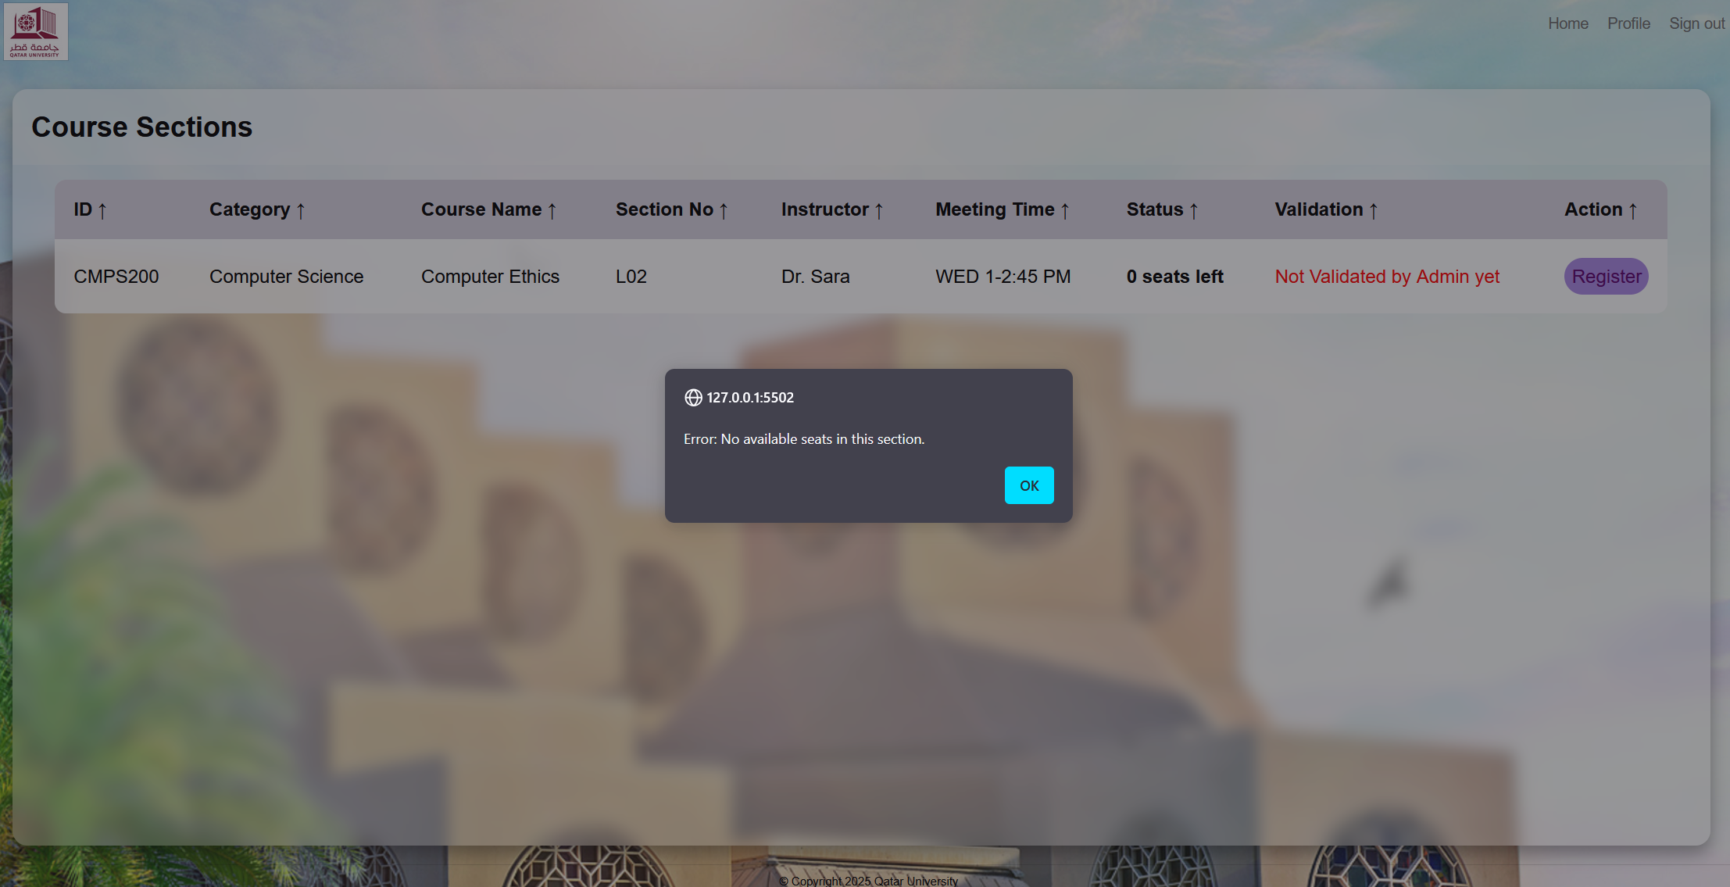

# Use case 4

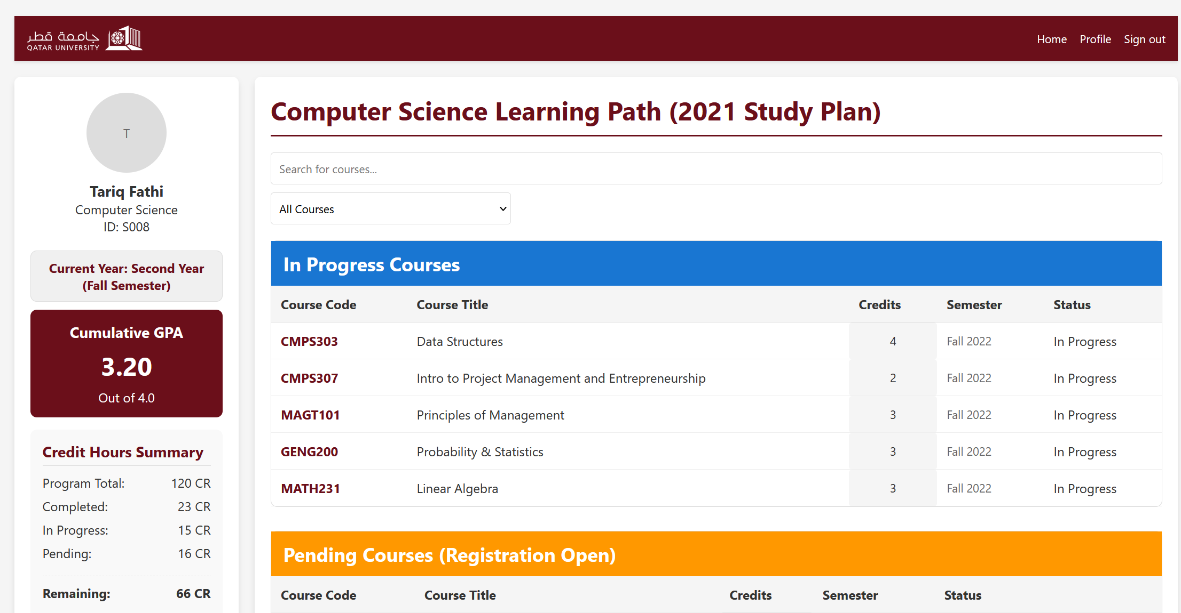

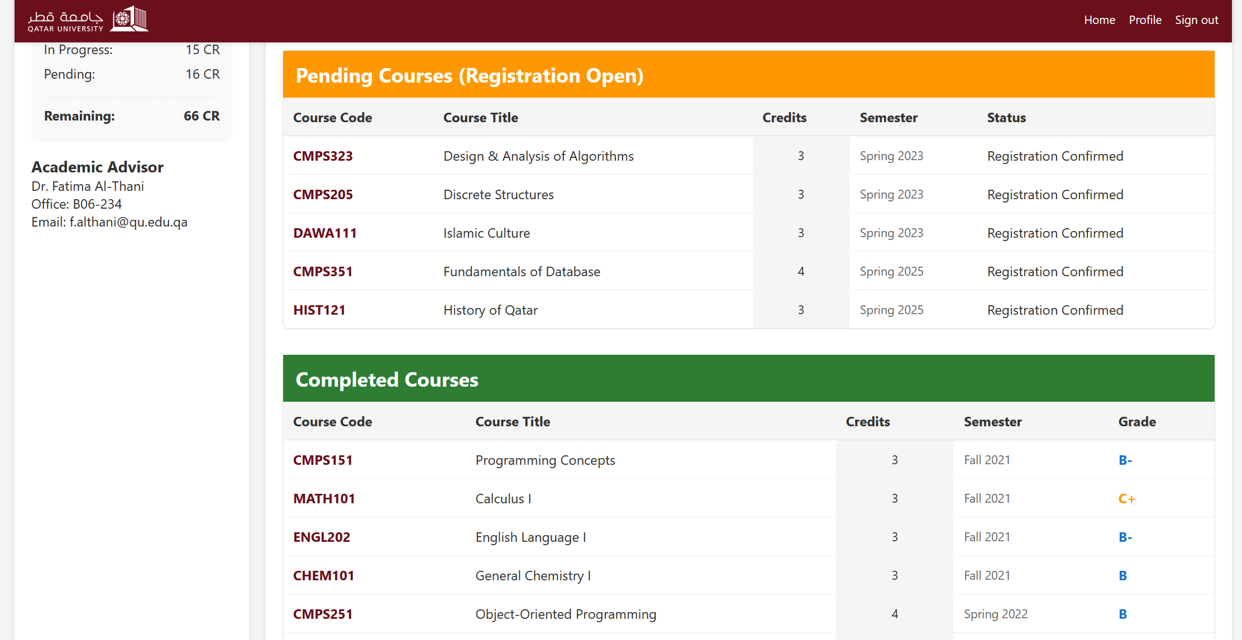

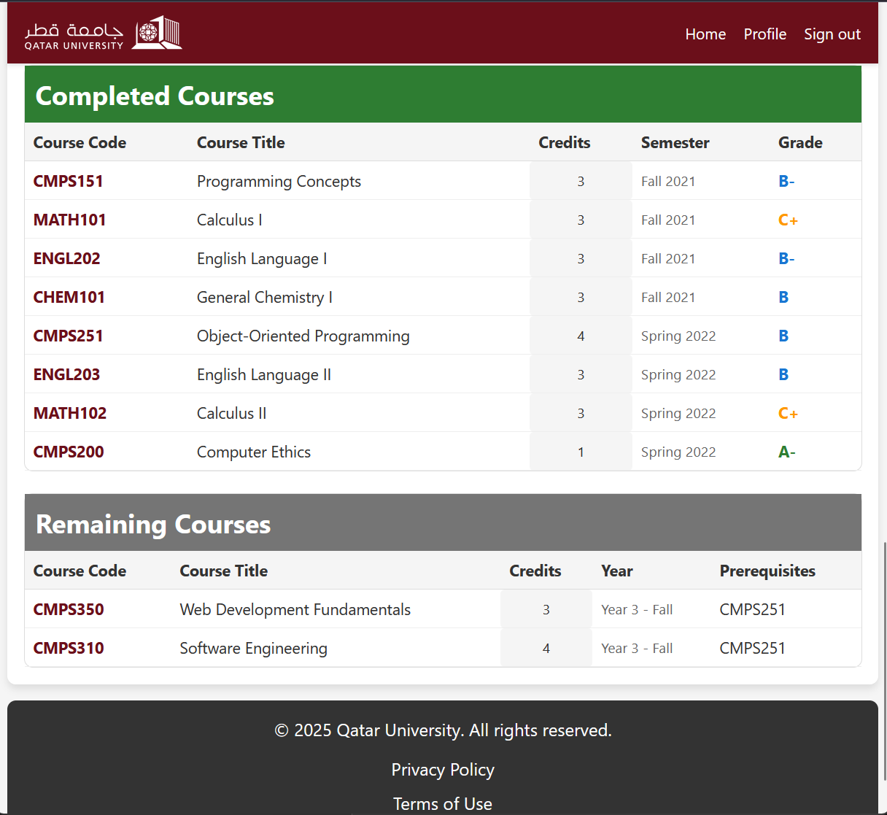

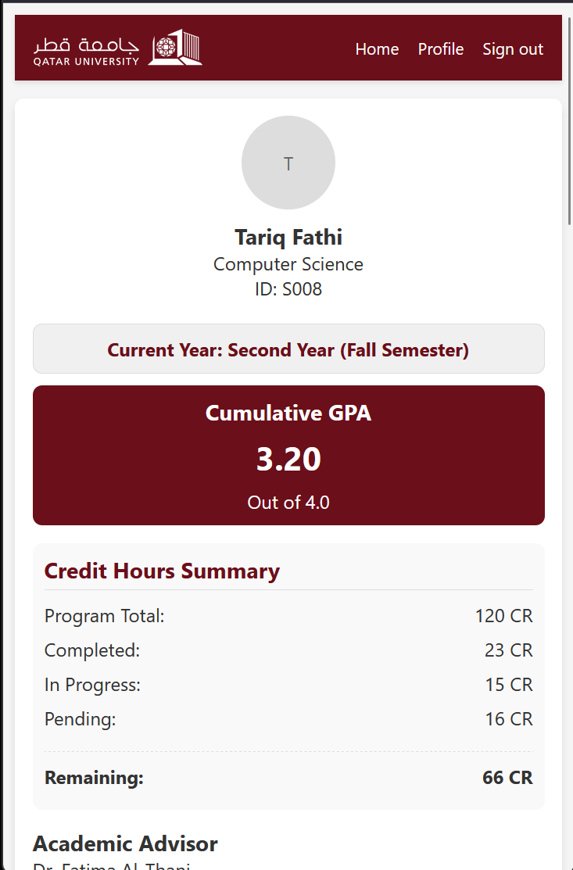

# Use case 5

1. Desktop view

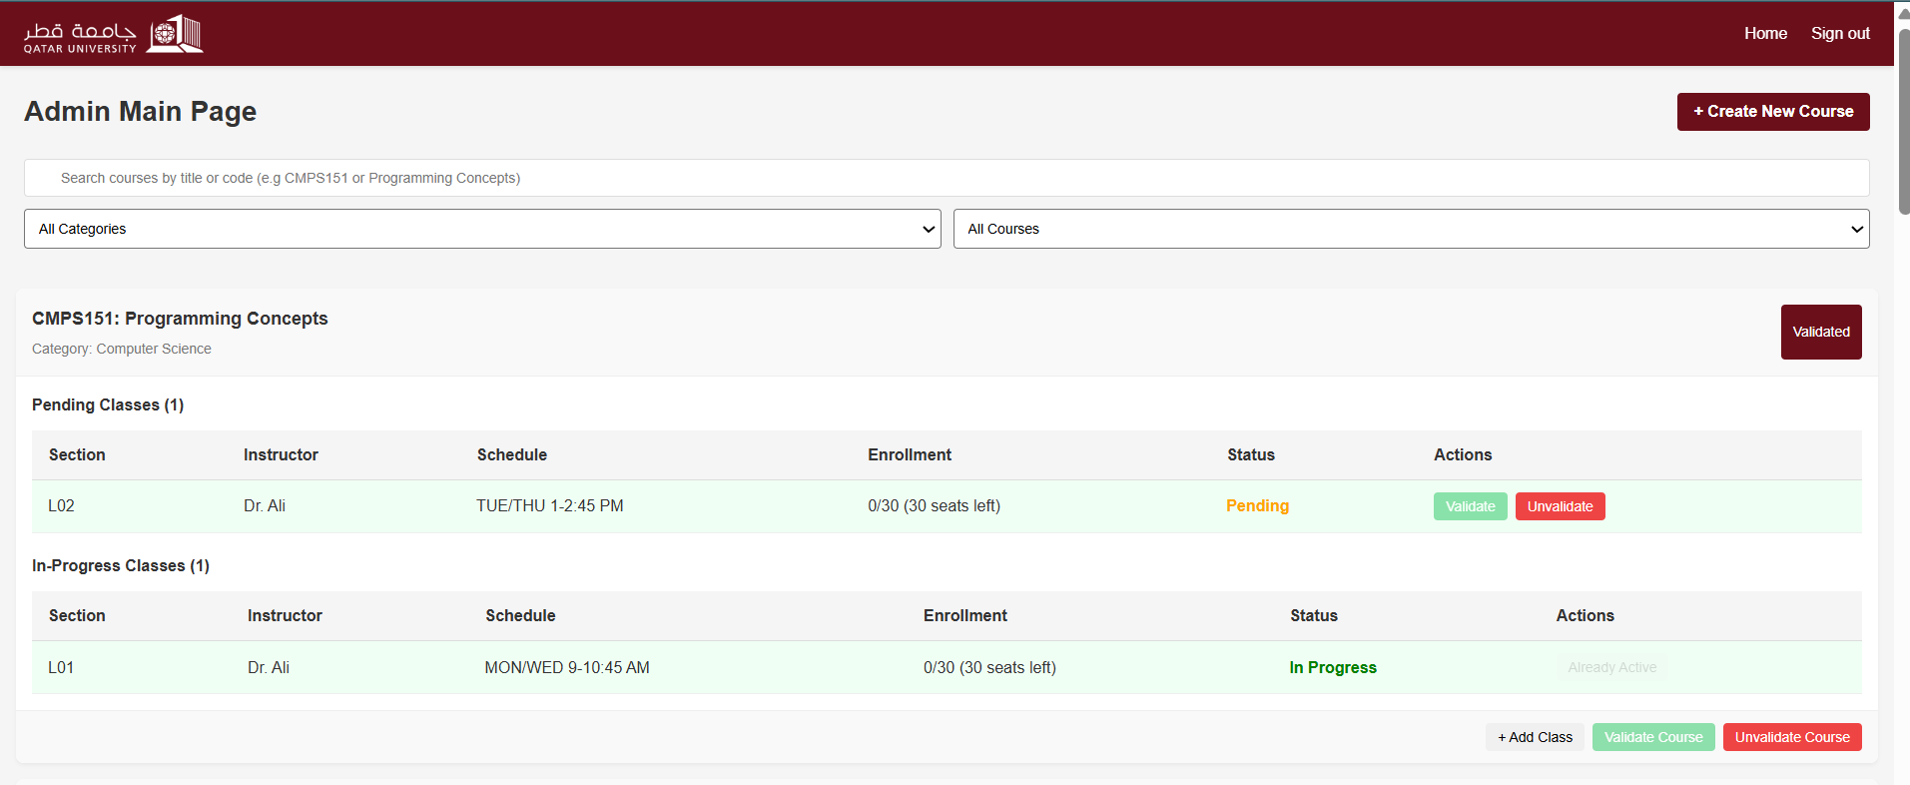

1. Mobile view

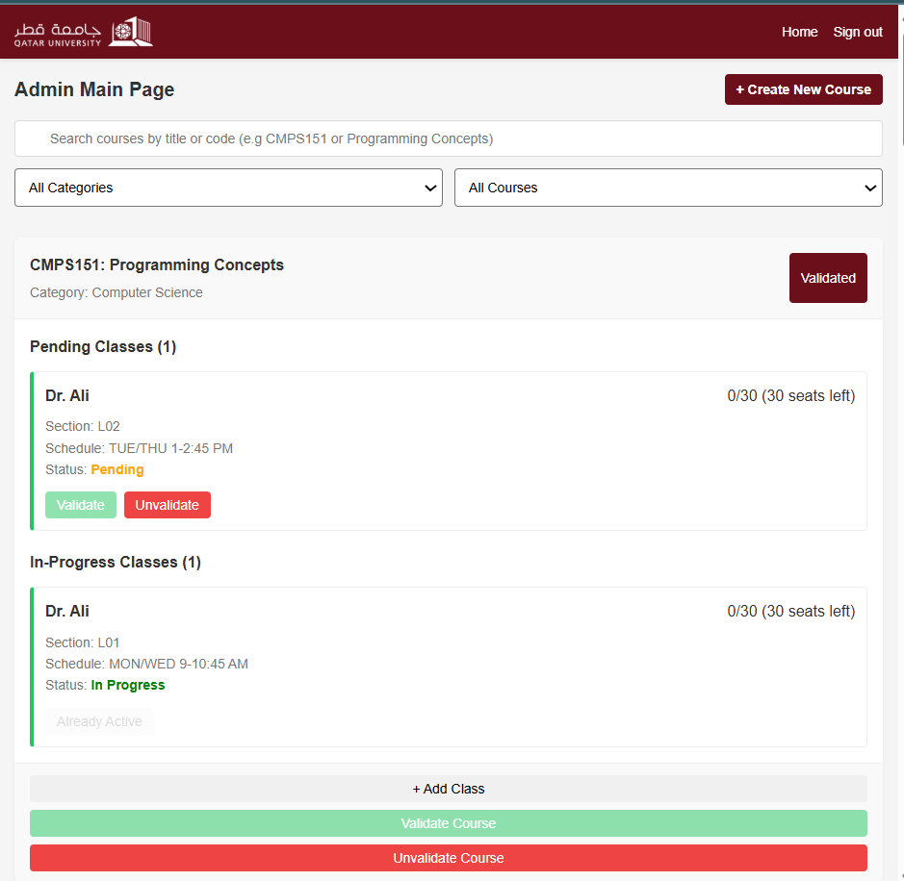

1. Add course

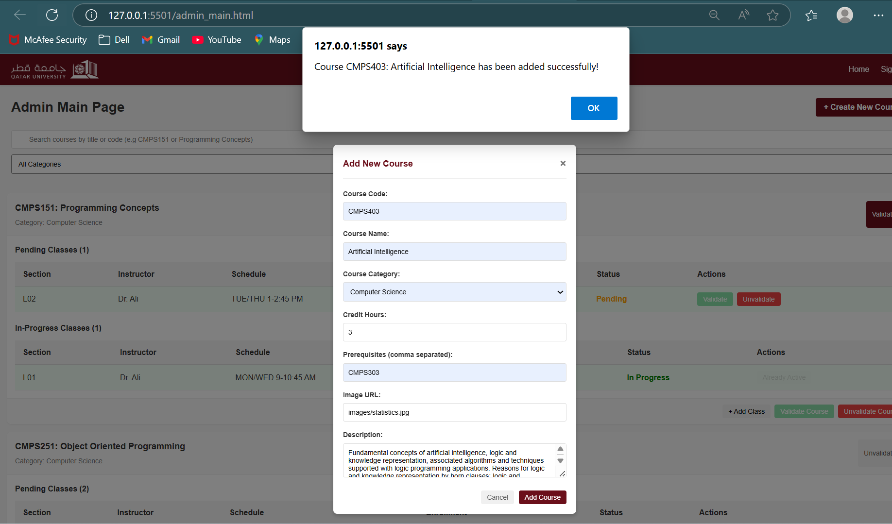

1. Add class to a course

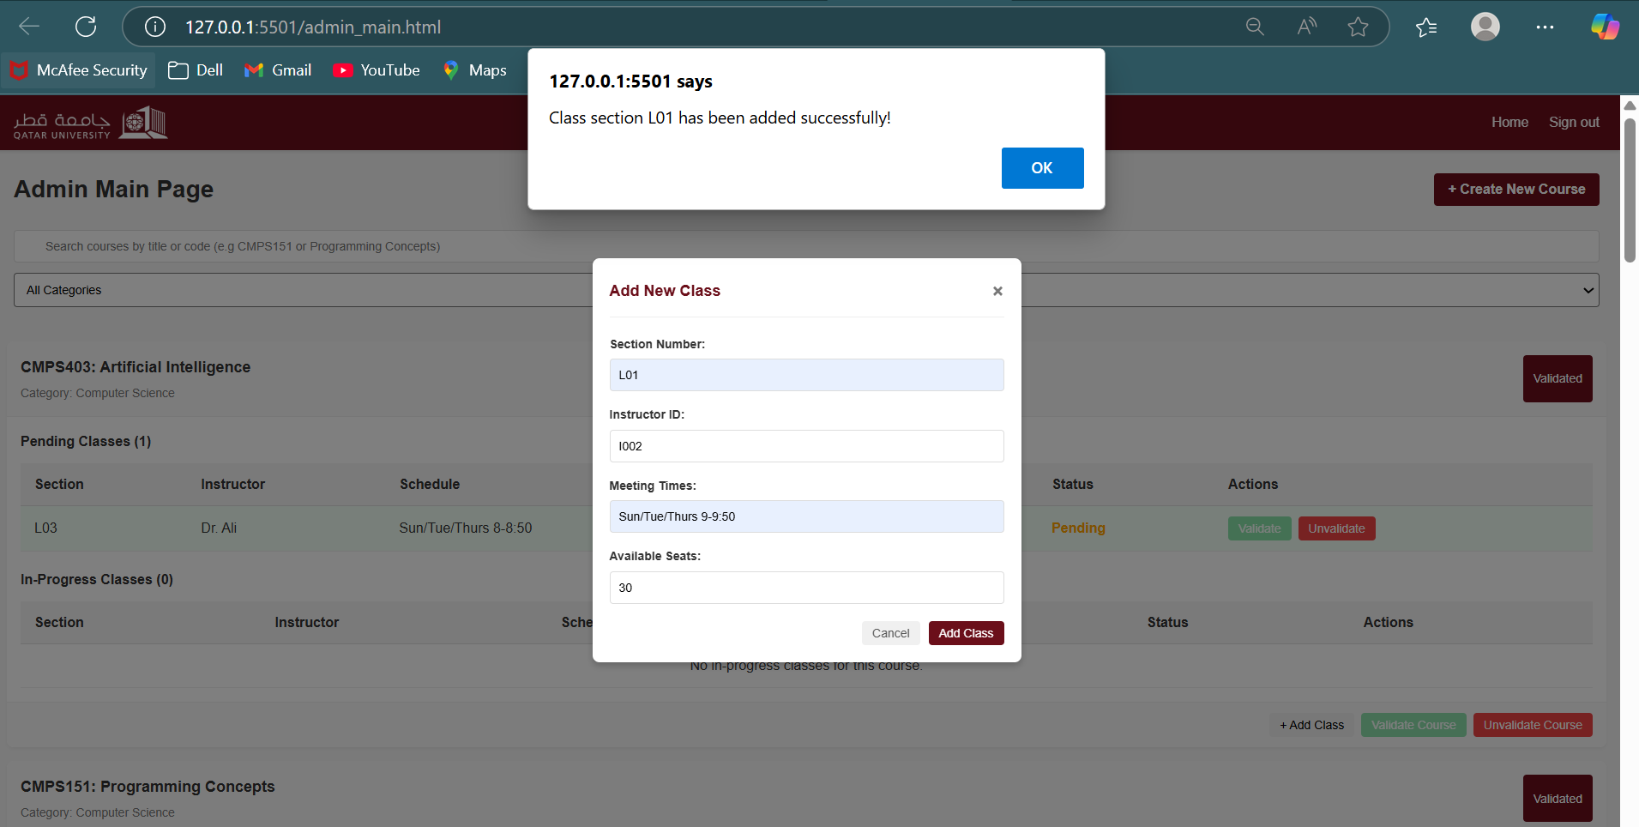

1. Validate course/ section

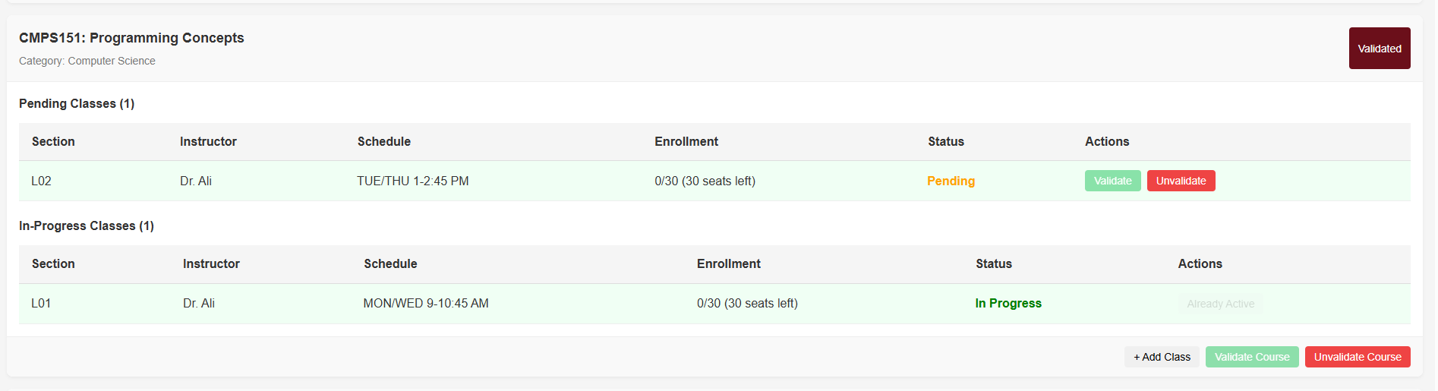

1. Invalidate section

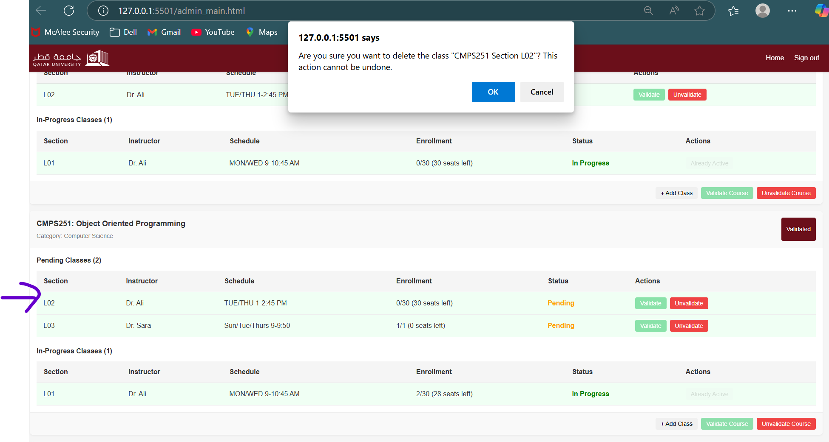

1. Invalidate course

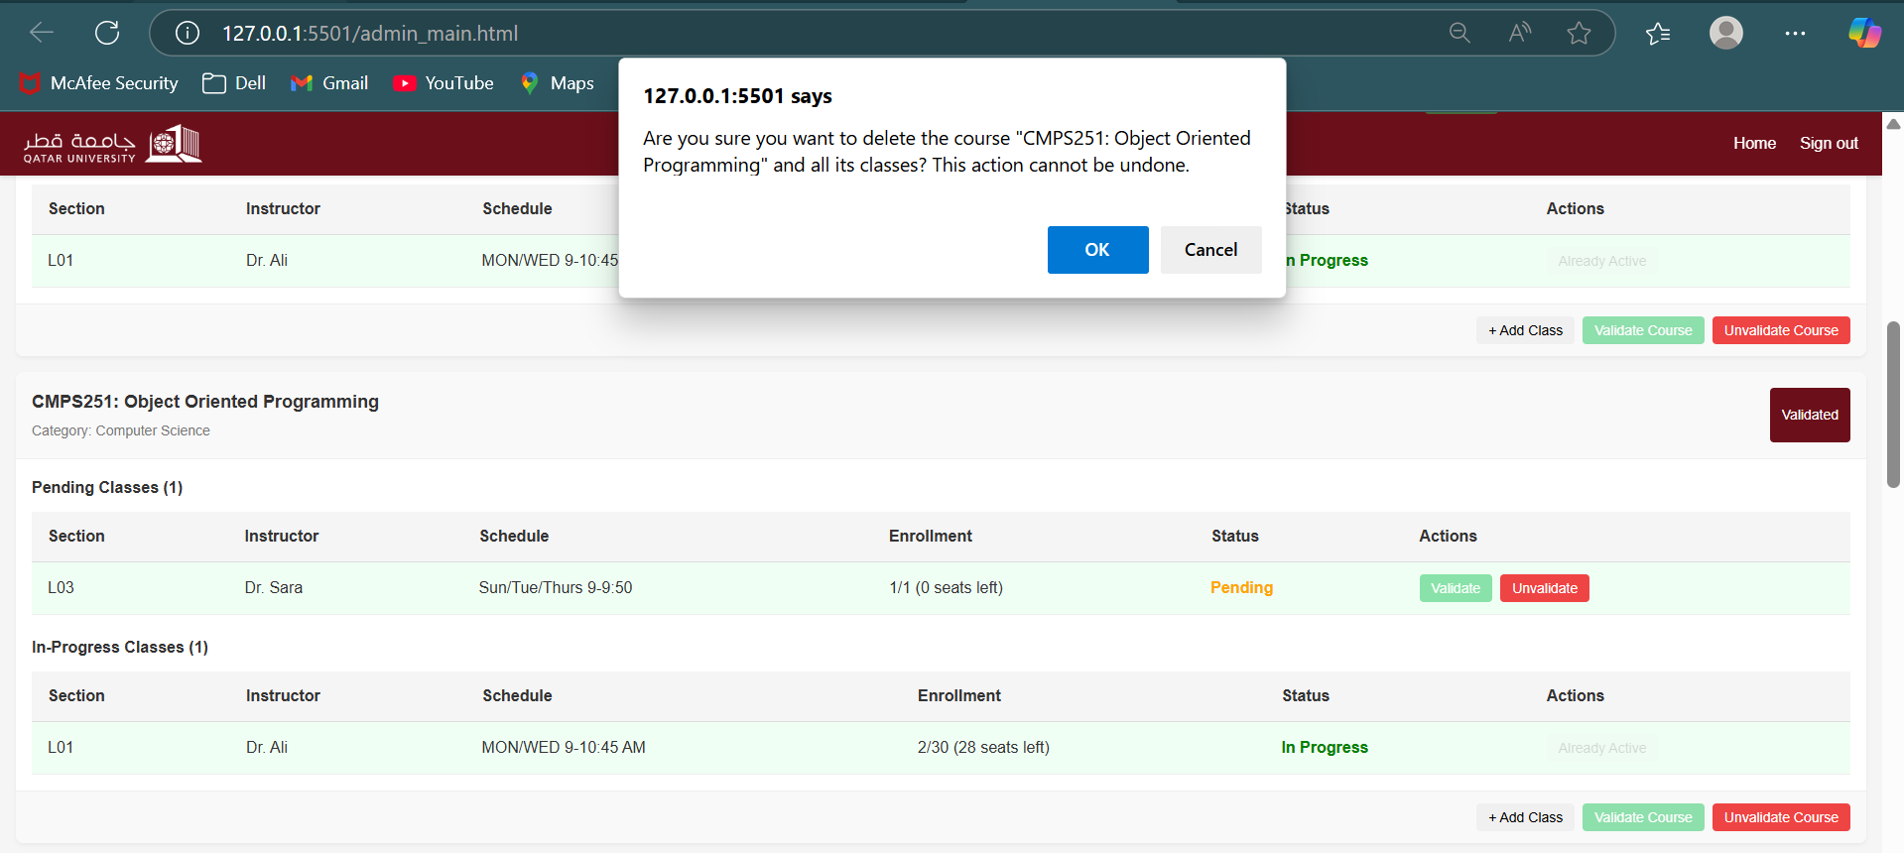

# Use case 6

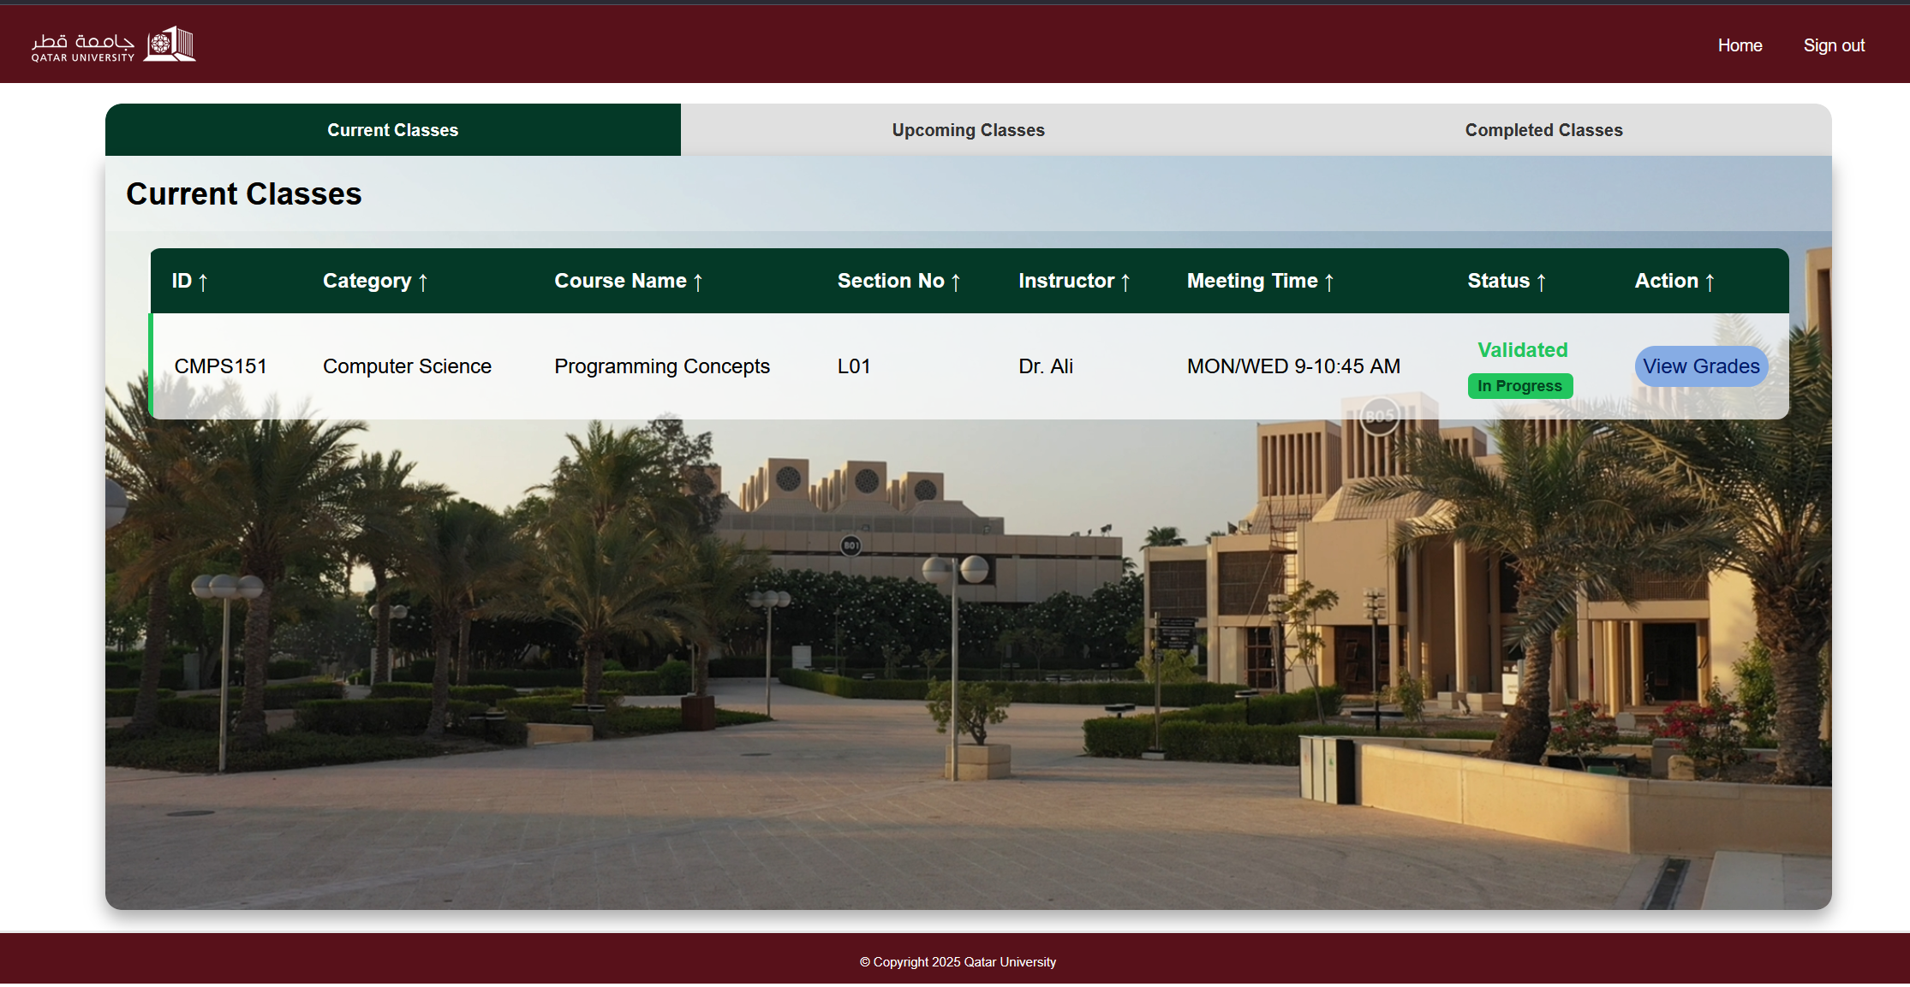

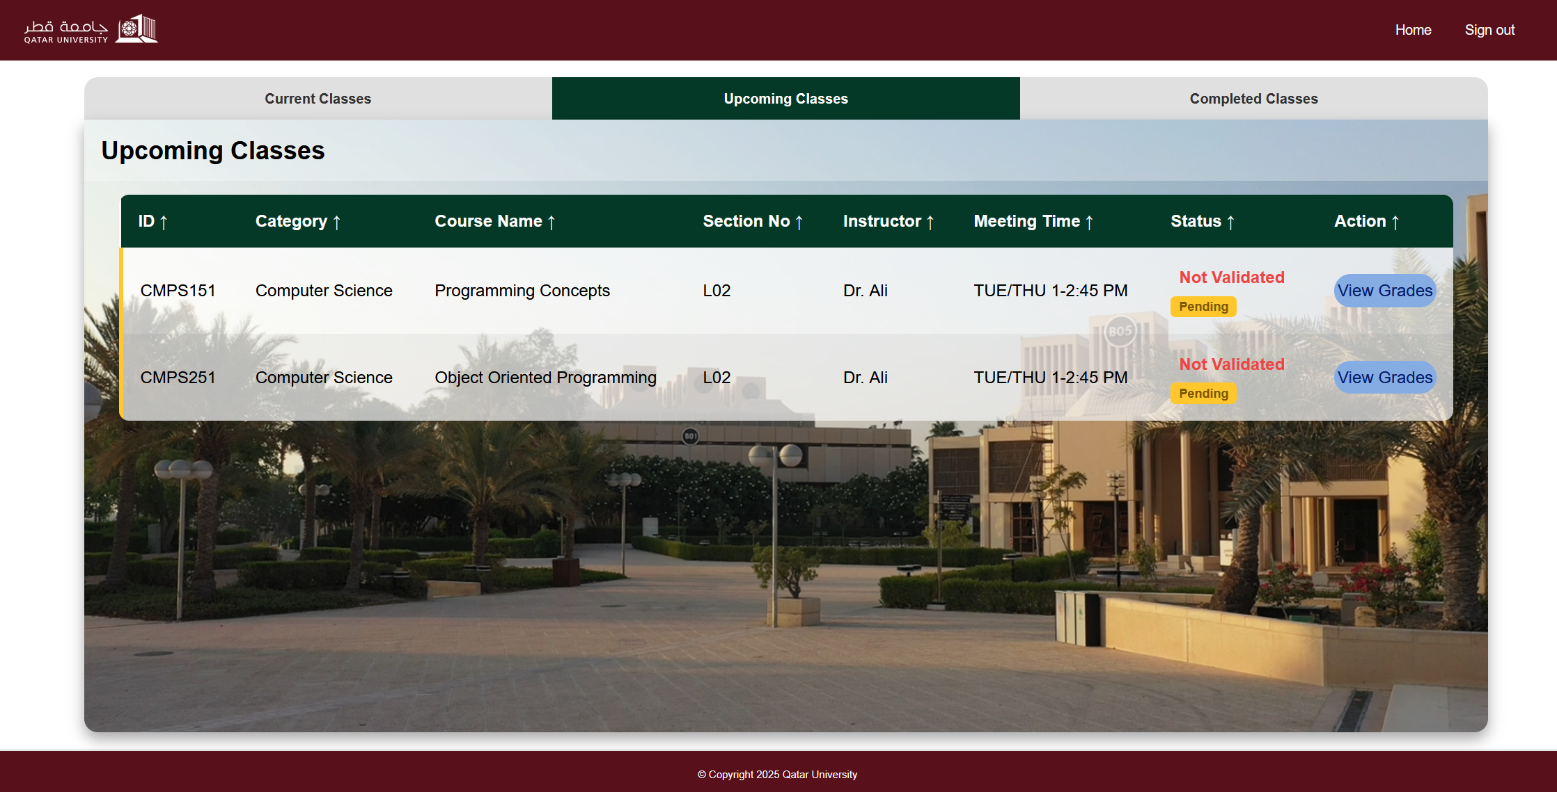

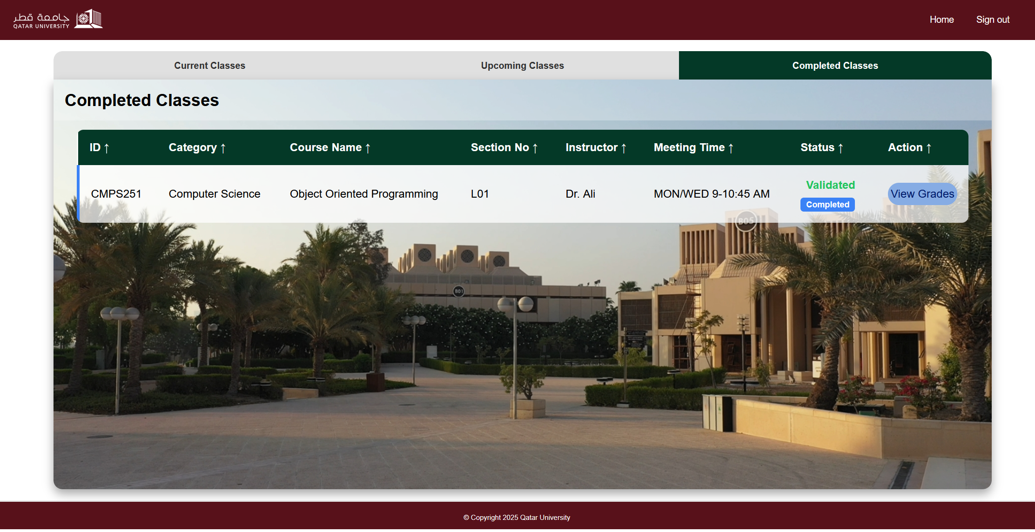

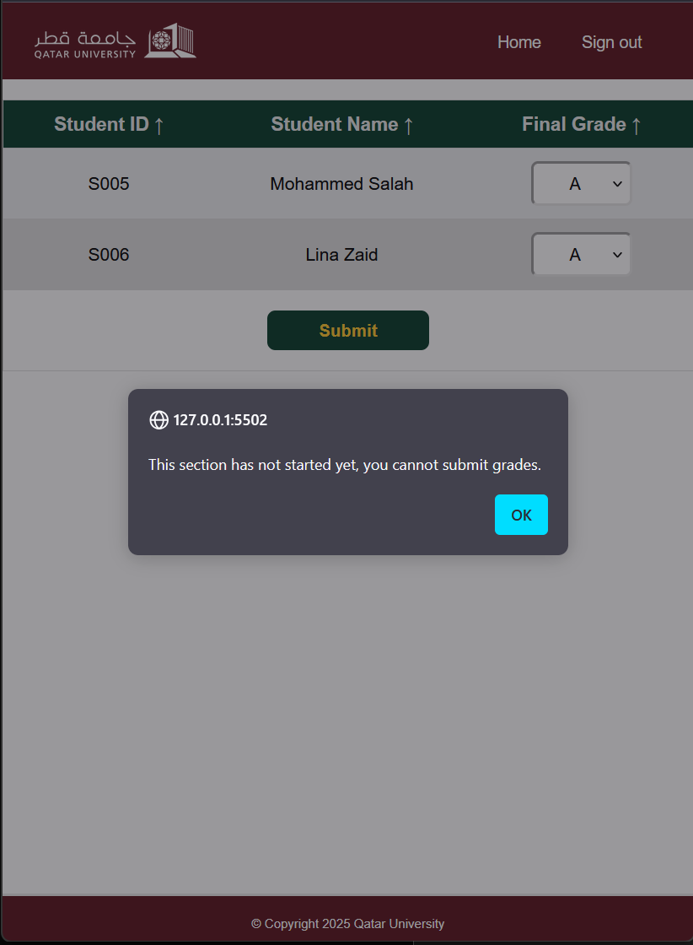 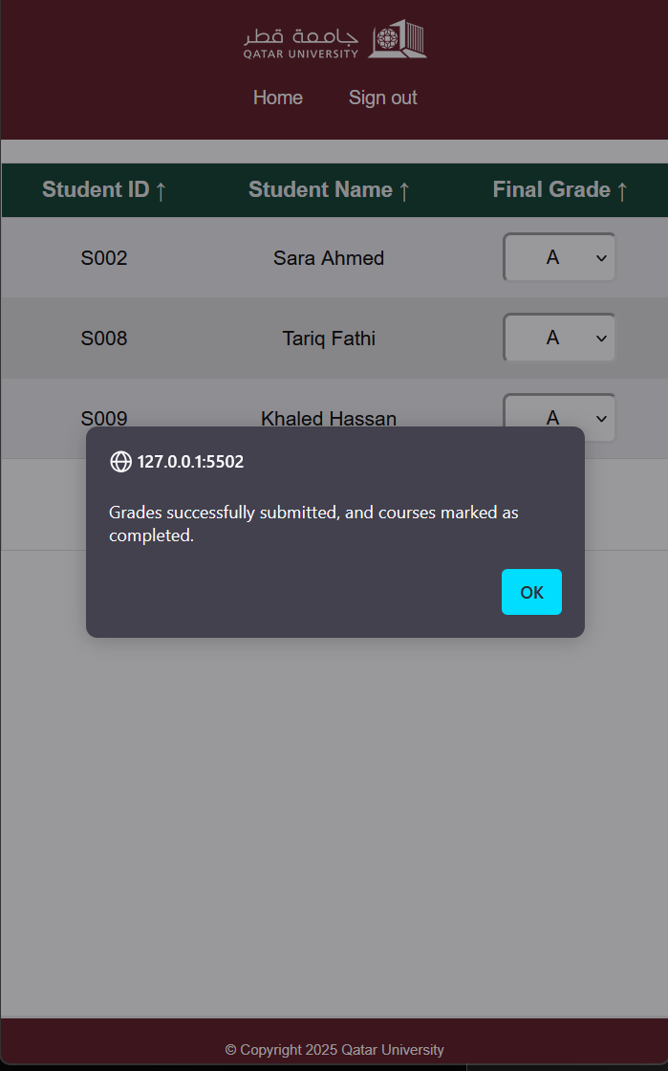

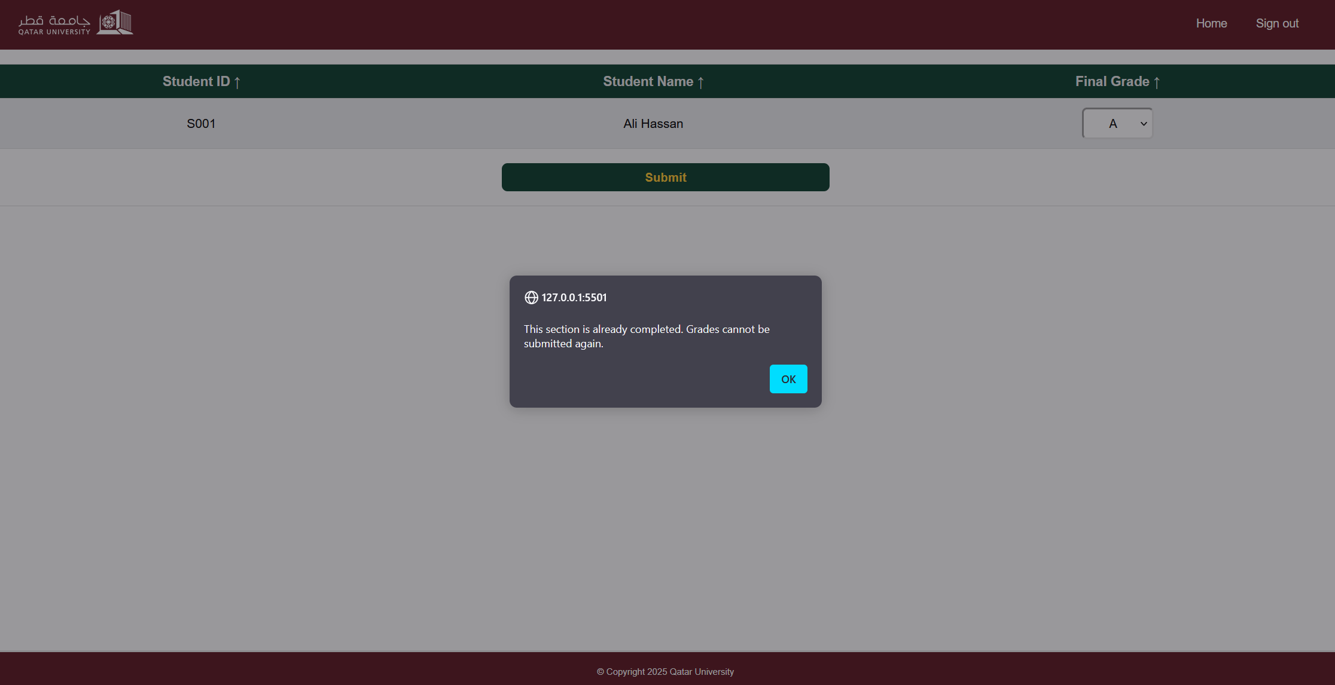

# Discussion of the project contribution of each team member

|  |  |
| --- | --- |
| **Student name** | **Student contributions** |
| Aiman Alhetari |  |
| Abdelrahman Kotb |  |
| Ahmed Mohamed |  |
|  |  |
|  |  |